**EXPERIMENT 5**

**1 Write a Program to Count the number of words in a String. (Execute for all return parameter values).**

<?php

echo "<b>20438 UMME ATIYA</b><br><hr>";

$str1 = "Betty had a bitter butter";

echo "String: " . $str1;

echo "<br>No. of words: ";

print_r(str_word_count($str1, 0));

echo "<br><br>Array with the words from string:<br>";

print_r(str_word_count($str1, 1));

echo "<br><br>Position of the words in string:<br>";

print_r(str_word_count($str1, 2));

echo "<br><br>With considering special character:<br>";

echo "No. of words: ";

print_r(str_word_count($str1, 0, "&") . "<br>");

print_r(str_word_count($str1, 2, "&"));

?>

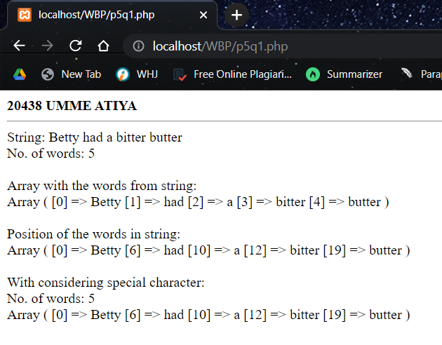

**2. Write a Program to Count the length of a String, to find the position of String and to compare two Strings.**

<?php

echo "<b>20438 UMME ATIYA</b><br><hr>";

$str1 = "Betty had a bitter butter";

$str2 = "Have a great day betty";

echo "String: " . $str1;

echo "<br>Lenght of a string: ";

print_r(strlen($str1));

echo "<br><br>Position of a 2nd betty in string:<br>";

echo strpos($str1, "betty", 12);

echo "<br><br>Comparing two strings::<br>";

echo strcmp($str1, $str2) . "<br>";

echo strcmp($str1, $str1) . "<br>";

echo strcmp($str2, $str1);

?>

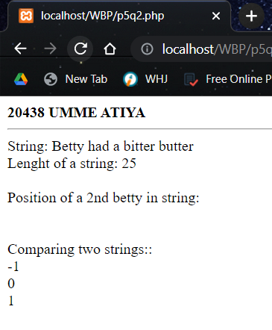

**3. Write a Program to Reverse a String.**

<?php

echo "<b>20438 UMME ATIYA</b><br><hr>";

$str = "Umme Atiya";

echo "String: " . $str;

echo "<br>Reverse a string: ";

echo strrev($str);

?>

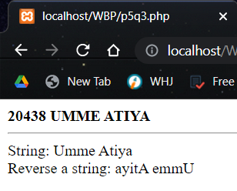

**4. Write a Program to Replace a String with the other String. Also count the number of replacements.**

<?php

echo "<b>20438 UMME ATIYA</b><br><hr>";

$str2 = "Have a great day";

$arr = array("PHP", "MAD", "PWP", "EDE");

echo "String: " . $str2;

echo "<br>Array String: ";

print_r($arr);

echo "<br><br>Normal find and replace:<br>";

echo str_replace("great", "wonderful", $str2);

echo "<br><br>Find and replace within array string:<br>";

print_r(str_replace("EDE", "ETI", $arr, $i));

echo "<br>Replacements: $i";

echo "<br><br>Find and replace with array find, array replace and array string<br>";

$find = array("have", "smile");

$replace = array("are");

echo "Array String: ";

$arr = array("You", "have", "beautiful", "smile");

print_r($arr);

echo "<br>";

print_r(str_replace($find, $replace, $arr, $i));

echo "<br>Replacements: $i";

?>

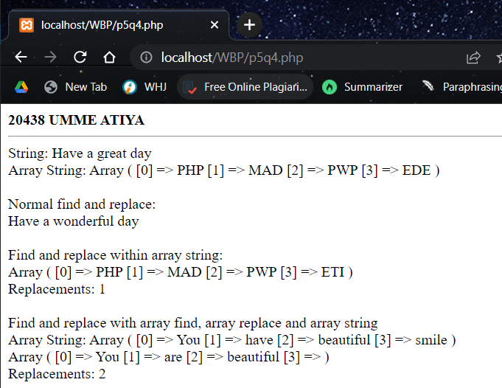

**5. Write a Program to convert the String to Uppercase, Lowercase, capitalize the first character of a string.**

<?php

echo "<b>20438 UMME ATIYA</b><br><hr>";

$str2 = "hAVe a gReaT day";

echo "String: " . $str2;

echo "<br><br>To Uppercase:<br>";

echo strtoupper($str2);

echo "<br><br>To Lowercase:<br>";

echo strtolower($str2);

echo "<br><br>Capitalize the first character of a

string:<br>";

echo ucwords($str2);

?>

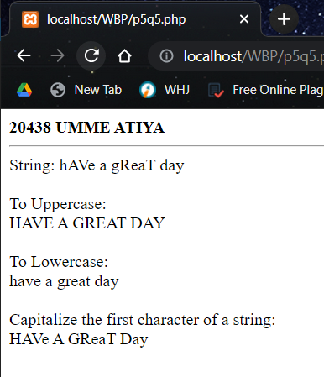

**EXPERIMENT 7**

**1. Write a Program to create an image in PHP.**

<?php

header('Content-Type:image/jpeg');

$img = imagecreate(300, 300);

imagecolorallocate($img, 255, 100, 124);

imagejpeg($img);

?>

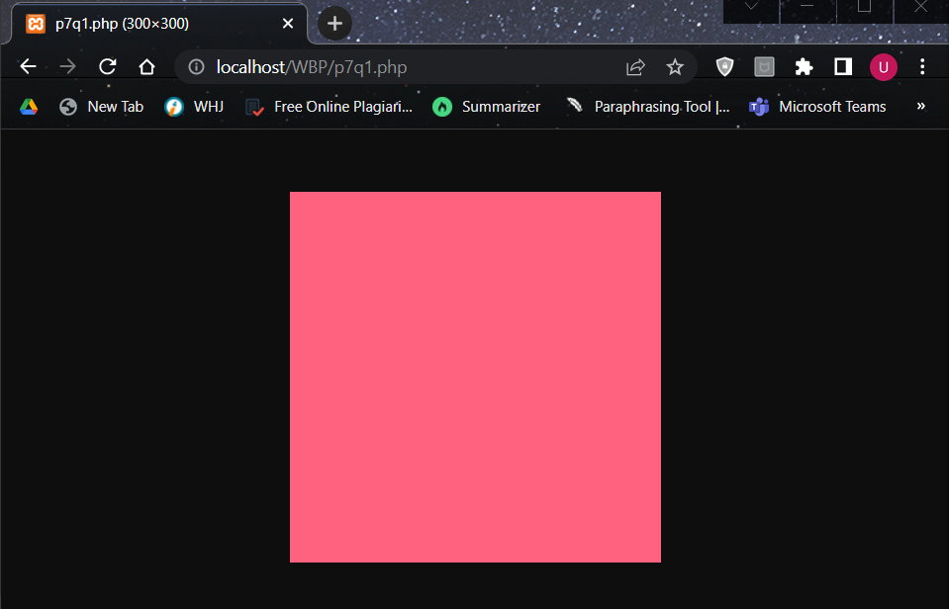

**2. Write a Program to create an image with text in PHP.**

<?php

header('Content-Type:image/jpeg');

$img = imagecreate(300, 300);

imagecolorallocate($img, 230, 135, 124);

$txt_color = imagecolorallocate($img, 0, 0, 0);

imagestring($img, 10, 20, 30, "UMME ATIYA", $txt_color);

imagejpeg($img);

?>

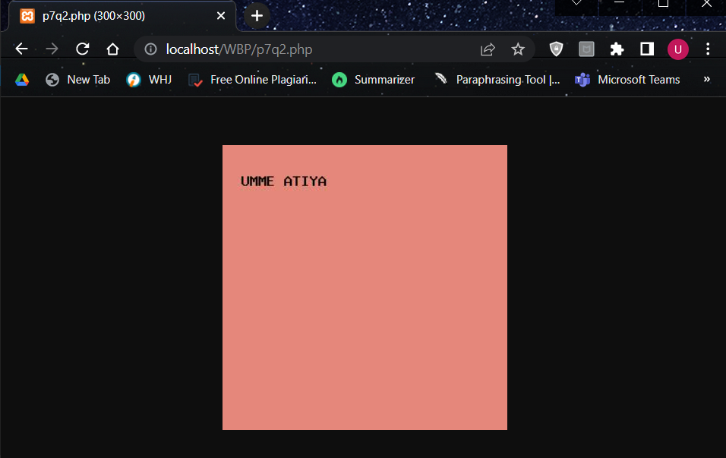

**3. Write a Program to create an image in PHP and display that image in HTML Page.**

PHP:

<?php

header('Content-Type:image/jpeg');

$img = imagecreate(300, 300);

imagecolorallocate($img, 230, 135, 124);

$txt_color = imagecolorallocate($img, 0, 0, 0);

imagestring($img, 10, 20, 30, "UMME ATIYA", $txt_color);

imagejpeg($img);

?>

HTML:

<html>

<head>

<title>Displaying images in HTML pages</title>

</head>

<body>

<img src="p7q2.php" />

</body>

</html>

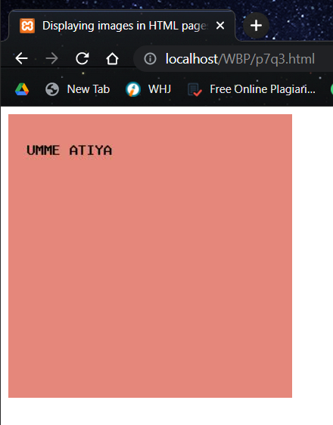

**4. Write a Program to demonstrate the use of imagecopyresized() and imagecopyresampled() functions.**

**PHP :**

<?php

header('Content-Type:image/webp');

$src = imagecreatefromwebp('WP.webp');

$w = ImageSx($src);

$h = ImageSy($src);

$x = $w / 8;

$y = $h / 8;

$dst = ImageCreateTrueColor($x, $y);

imagecopyresized($dst, $src, 0, 0, 0, 0, $x, $y, $w, $h);

imagejpeg($dst);

?>



<?php

header('Content-Type:image/webp');

$src = imagecreatefromwebp('WP.webp');

$w = ImageSx($src);

$h = ImageSy($src);

$x = $w / 8;

$y = $h / 8;

$dst = ImageCreateTrueColor($x, $y);

imagecopyresampled($dst, $src, 0, 0, 0, 0, $x, $y, $w, $h);

imagejpeg($dst);

?>

HTML:

<html>

<head>

<title>Displaying images in HTML pages</title>

</head>

<body>

<h3>Image generated from imagecopyresized()

<br><img src="p7q4.php">

<hr><h3>Image generated from imagecopyresampled()

<br><img src="p7q5.php">

</body>

</html>

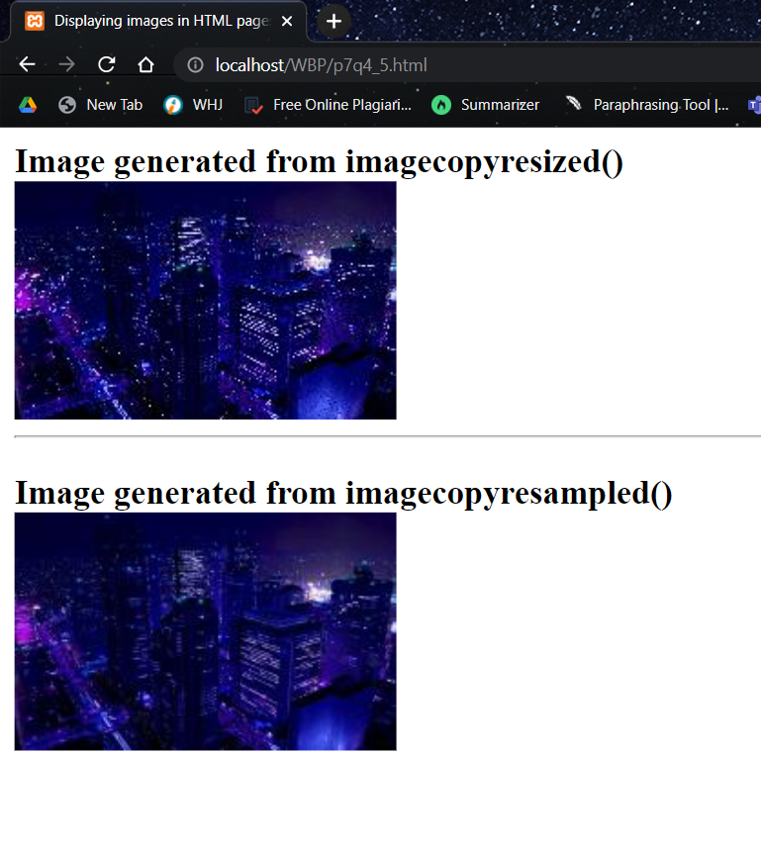

**5. Write a Program to generate a PDF using FPDF.**

**PHP:**

<?php

require('fpdf.php');

$pdf = new FPDF();

$pdf->AddPage();

$row = file('students.txt');

$pdf->SetFont('Arial', 'B', 13);

$pdf->Cell(90, 10, 'Student Information');

$pdf->Ln();

foreach ($row as $rowValue) {

$data = explode(';', $rowValue);

foreach ($data as $columnValue)

$pdf->Cell(60, 12, $columnValue, 1);

$pdf->SetFont('Arial', '', 12);

$pdf->Ln();

}

$pdf->Output();

?>

**TXT:**

Roll No;Name;Branch

20438;Umme Atiya;Computer

19301;Rahul;Electrical

19322;Kavya;Electrical

19513;Barkha;Mechanical

20111;Sakshi;Computer

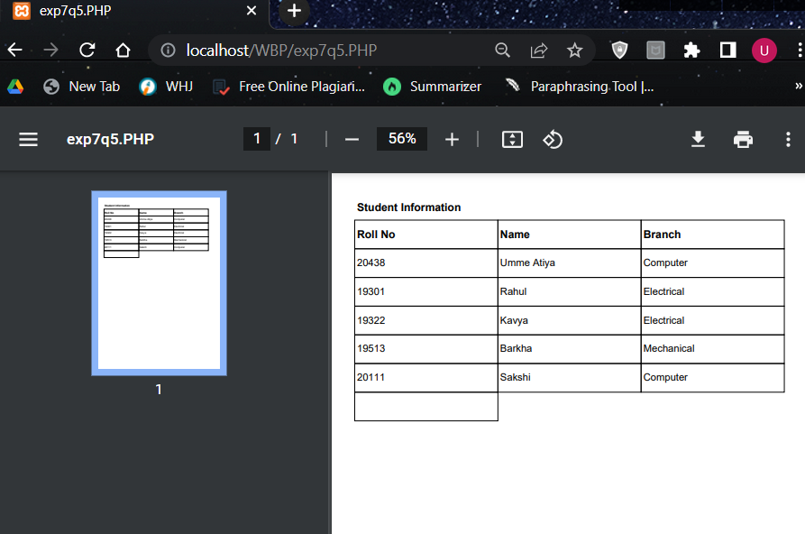

**EXPERIMENT 6**

Q1 Write a Program to demonstrate Pass by Value using function.

<?php

echo "Umme Atiya : 20438 <br><hr>";

function cal($a)

{

$a++;

echo "Pass by value inside a function ".$a."<br>";

}

$a=5;

echo "Pass by value before increment " .$a."<br>";

cal($a);

echo "Pass by value outside a function  " .$a. "<br>";

?>

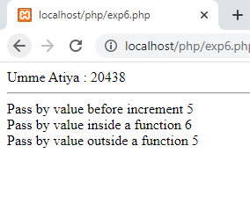

Q2 Write a Program to demonstrate Pass by Reference using function.

<?php

echo " Umme Atiya 20438<br><hr>";

function cal(&$a)

{

$a++;

echo "Pass by reference inside a function ".$a."<br>";

}

$a=5;

echo "Pass by reference before increment " .$a."<br>";

cal($a);

echo "Pass by reference outside a function  " .$a. "<br>";

?>

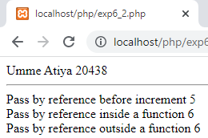

Q3. Write a Program to demonstrate default arguments in function.

<?php

echo "20438 Umme Atiya <br><hr>";

function cal($a,$b="atiya")

{

echo "$a $b<br>";

}

cal("hellloo");

?>

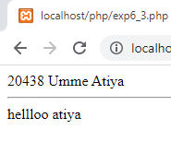

Q4. Write a program to create a Variable function.

<?php

echo "20438 : UMME ATIYA <br><hr>";

function cal($a)

{

echo "Hello $a<br>";

}

$x='cal';

$x("Umme atiya");

?>

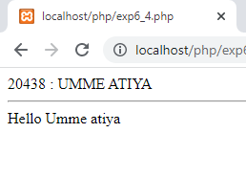

Q5. Write a Program for Anonymous function using variable.

<?php

echo "20438 : UMME ATIYA <br><hr>";

$add=function($a,$b){

return $a+$b;

};

echo "Addition:".$add(2,2);

?>

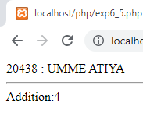

Q 6. Write a Program for Anonymous function using array.

<?php

echo "20438 : UMME ATIYA  <br><hr>";

$arr=array(

    (function($a,$b){

        echo $a+$b;

        }),

(

    function(){

        echo "<br>This is 1st index";

    }

)

);

$v1=$arr[0];

$v1(2,2);

$v2=$arr[1];

$v2();

?>

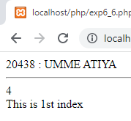

Q7. Write a Program to implement the concept of Callback using Anonymous function.

<?php

echo "20438 : UMME ATIYA <br><hr>";

$num=array(1,2,3,4,5);

$arr=array_map(function($num)

{

return $num+$num;

},$num);

echo "Original Array<br>";

print_r($num);

echo"<br>";

echo "New Array<br>";

print_r($arr);

?>

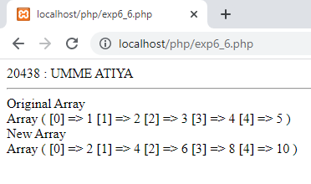

Q8. Write a Program to implement the concept of Closure using Anonymous function.

<?php

echo "20438 : UMME ATIYA <br><hr>";

$a=" Umme Atiya";

$message=function() use ($a){

echo "Hello ".$a;

};

$message();

?>

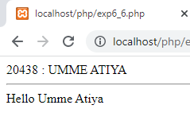

Q1 Write a Program to create an image in PHP.

<?php

header("Content-Type:image/jpeg");

$image1=imagecreate(480,320);

$bgcolor=imagecolorallocate($image1,240,240,140);

imagejpeg($image1)

?>

